B
ST. FLANNAN’S COLLEGE
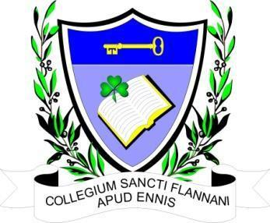
BOARD MEETING. Extraordinary Meeting
AGREED REPORT
Date and Time of Meeting | Wednesday, May 10^{th,} 2023 at 6.30 pm.
Present | Mr. Leonard Cleary (Chairperson), Mr. Pat Whyms , Ms. Mary Keane, Dr. Denise Cox, Mr. Christy O’Connor and Mr. Benny Duggan.  Tracey O’Donohue (Recording Secretary)
Apologies from | Fr Ignatius McCormack (Secretary), Ms. Mary Corbett, Ms. Elaine Duffy.

The meeting opened with a prayer from the Chairman.

The Chairman welcomed the Board.

- Agenda. Single agenda meeting with regard to the planning permission granted by Clare County Council to build an elderly care hospital on St Flannan’s grounds.

An addition to the agenda requested in relation to the role of the Board. The agenda was agreed by the Board by consensus.

- The Board’s attention to the guidance manual for school boards of management, particularly to the role and responsibilities of the Board concerning the students and the Patron.

3. The Board discussed at length the possibility of appealing to An Bord Pleanála to the proposed
development on the school grounds. The decision was made to meet again when Fr McCormack is
available to attend. It was noted that there is a very short timeframe for the appeal and therefore
the meeting must be very soon.

4. The date of the next meeting is to be decided.

