B
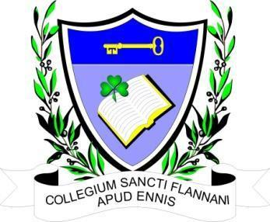

ST. FLANNAN’S COLLEGE
BOARD MEETING.
AGREED REPORT
Date and Time of Meeting | Wednesday, 14th August 2023 at 6.30 pm. Via Zoom
Present | Mr. Leonard Cleary (Chairperson), Fr Ignatius McCormack (Secretary), Mr. Pat Whyms, Mr. Christy O’Connor, Ms. Mary Corbett, Dr. Denise Cox Ms. Elaine Duffy, Ms. Mary Keane.  Tracey O’Donohue (Recording Secretary).
Apologies from | Mr. Benny Duggan.

The meeting opened with a prayer from Fr McCormack.

The Chairman welcomed the Board and thanked them for their attendance.

1. Agenda. The agenda was agreed by consensus.

2. Documents regarding the upcoming Deputy Principal post were previously circulated. The use of
these documents and also the engagement of the Patron’s proposed representatives to the
interview panel previously agreed in the minutes of June 14th , were both agreed by the Board.

3. AOB. The principal informed the Board that the school has been granted 25 extra teaching hours
for the coming school year. He requested that the Board approve their use for SEN teaching. This was approved by the Board.

The principal informed the Board of a letter received from a staff member informing the Board of
their intention to retire in November. He then requested the Board’s consent to advertise the job.
This was approved by consensus.

4. Agreed Report. Will be the minutes with all personal information removed.

5. The next meeting is to be decided.

