B
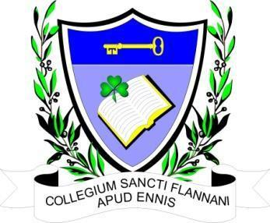

ST. FLANNAN’S COLLEGE
BOARD MEETING.
AGREED REPORT
Date and Time of Meeting | Wednesday, 14th June 2023 at 6.00 pm. Via Zoom
Present | Mr. Leonard Cleary (Chairperson), Fr Ignatius McCormack (Secretary), Mr. Pat Whyms, Mr. Christy O’Connor, Ms. Mary Corbett, Dr. Denise Cox, Mr. Benny Duggan.  Tracey O’Donohue (Recording Secretary).
Apologies from | Ms. Elaine Duffy, Ms. Mary Keane.

The meeting opened with a prayer from Fr McCormack.

The Chairman welcomed the Board and thanked them for their attendance.

- Agenda. The agenda was agreed by consensus.

2. Minutes. The minutes were adopted by the Board.

3. Matters Arising.
An Bord Pleanála has acknowledged receipt of our planning objection.

4 Correspondence.
A request for six weeks of Parental Leave in September was received from a staff member. The leave was approved by the Board.

5. The principal requested the Board’s agreement to advertise the vacancy for a Deputy Principal in the middle of August. This was agreed by the Board.

The principal requested the Board’s agreement to the formation of an interview panel with respect to the vacant DP post. The panel will consist of two board members, two patron’s representatives, (to be agreed with the Patron), and an independent Chair. This was agreed by the Board.

6. The principal put forward names of candidates who were successful in interview.

All were approved by the Board.

7. Agreed Report. Will be the minutes with all personal information removed.

8. The next meeting is to be decided.

