B
ST. FLANNAN’S COLLEGE
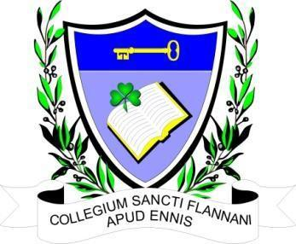
BOARD MEETING.
Agreed Report
Date and Time of Meeting | Monday, September 4th, 2023, at 6.30 pm. Zoom meeting
Present | Mr. Leonard Cleary (Chairperson), Fr Ignatius McCormack (Secretary), Mr. Pat Whyms, Dr. Denise Cox Ms. Elaine Duffy, Mr. Christy O’Connor, Mr. Benny Duggan, Ms. Mary Corbett.  Tracey O’Donohue (Recording Secretary).
Apologies from

The meeting opened with a prayer from Fr McCormack.

The Chairman welcomed the Board.

- Agenda. The agenda was agreed by consensus.

2. Child Protection. There were no incidences involving child protection.

3. Affirmation of the selection committee for the Deputy Principal vacancy

The nominees were all affirmed by the Board.

Interviews will take place on September 18th, 2023.

4. Interview for AP1 and temporary AP1 posts will take place during the week of September 25th.

5. A letter was read-in a from An Bord Pleanála informing the school that there would be no oral hearing in the case of the planning objection.

6. Agreed Report. Will be the minutes with all personal information removed.

Next meeting will be September 18th following the Deputy Principal interviews.

