B
ST. FLANNAN’S COLLEGE
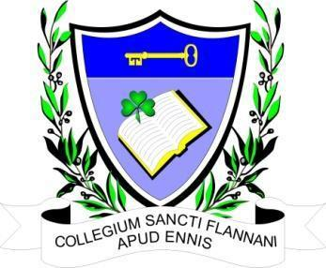
BOARD MEETING. Extraordinary Meeting
AGREED REPORT
Date and Time of Meeting | Tuesday, May 18^{th,} 2023 at 6.30 pm via Zoom.
Present | Fr Ignatius McCormack (Secretary), Mr. Pat Whyms , Ms. Mary Keane, Dr. Denise Cox, Mr. Benny Duggan, Mr. Christy O’Connor, Ms Mary Corbett.  Tracey O’Donohue (Recording Secretary).
Apologies from | Mr. Leonard Cleary (Chairperson), Ms. Elaine Duffy.

The meeting opened with a prayer from Fr McCormack.

The acting Chairman welcomed the Board.

- Agenda. Single agenda meeting regarding the engagement of a planning consultant for the purpose of appealing the planning decision of Clare County Council.

2. After many phone conversations with consultants who deal with planning issues, some of whom
had conflicts of interest due to their work with the HSE, some of whom were just too busy to take
on the work in the short time frame that is left to us. It was reported to the Board that they had
been unable to engage a planning consultant and sought suggestions for action going forward.
There is still one call that has not been returned.

After discussion, it was decided that if at close of business tomorrow, Wednesday 19th May, the
Board was still unable to engage a planning consultant, the Secretary, and three members of the
Board will meet and resubmit the objection letter that was previously sent to the Council.

3. The date of the next meeting is Wednesday 24th May.

