B
ST. FLANNAN’S COLLEGE
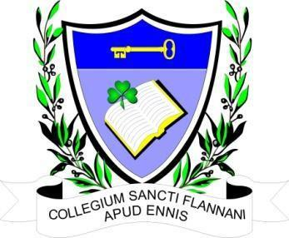
BOARD MEETING. Extraordinary Meeting
Agreed Report
Date and Time of Meeting | Tuesday, May 16^{th,} 2023 at 6.30 pm.
Present | Mr. Leonard Cleary (Chairperson), Fr Ignatius McCormack (Secretary), Mr. Pat Whyms , Ms. Mary Keane, Dr. Denise Cox, Mr. Benny Duggan, Ms. Elaine Duffy, Ms Mary Corbett.
Apologies from | Mr. Christy O’Connor, Tracey O’Donohue (Recording Secretary).

The meeting opened with a prayer from Fr McCormack.

The Chairman welcomed the Board.

- Agenda. Single agenda meeting regarding the engagement of a solicitor for the purpose of appealing the planning decision of Clare County Council.

2. The Board was informed of efforts thus far in engaging a planning consultant, letting them know
that the consultant, whom the Board has decided to approach at the previous meeting, is
unavailable. He in turn had recommended a consultant closer to our location. There has been no
success with contacting her and the assistance of two other Board members was requested in the
efforts to engage a planning consultant, two Board members agreed to do so.

3. The date of the next meeting is to be decided.

